# Project Report

On

# Face Mask Detection using OpenCV

***Submitted in partial fulfillment of the requirement for the award of the degree of***

B. Tech, Computer Science & Engineering

Under Supervision

## Ms. Madhu

Technical Trainer

Submitted By:

**Shubhneet Kumar**

(201500685)

**Vishal Rajput**

(201500794)

**Prashant Pachauri**

(201500506)

**Jigyas Chaudhary**

(201500317)

**DEPARTMENT OF COMPUTER SCIENCE AND ENGINEERING, GLA UNIVERSITY, MATHURA, INDIA**

APRIL, 2023

# BONAFIDE CERTIFICATE

Certified that this project report **“Face Mask Detection Suing OpenCV”** is the bonafide work of ‘Shubhneet Kumar, Jigyas Chaudhary, Vishal Rajput, Prashant Pachauri’ who carried out the project work under my/our supervision.

**SIGNATURE SIGNATURE**

Rohit Agrawal Ms. Madhu

**HEAD OF THE DEPARTMENT TECHNICAL TRAINER**

Computer Science and Engineering Training and Development

Submitted for the viva-voice examination held on 27 April 2023

**INTERNAL EXAMINER EXTERNAL EXAMINER**

# ACKNOWLEDGEMENT

It gives us a great sense of pleasure to present the synopsis of the B.Tech mini project undertaken during B.Tech III Year. This project is going to be an acknowledgement to the inspiration, drive and technical assistance will be contributed to it by many individuals. We owe special debt of gratitude to Ms. Madhu, Technical Trainer, for providing us with an encouraging platform to develop this project, which thus helped us in shaping our abilities towards a constructive goal and for his constant support and guidance to our work. His sincerity, thoroughness and perseverance has been a constant source of inspiration for us. We believe that he will shower us with all his extensively experienced ideas and insightful comments at different stages of the project & also taught us about the latest industry-oriented technologies. We also do not like miss the opportunity to acknowledge the contribution of all faculty members of the department for their kind guidance and co-operation.

Shubhneet kumar(201500685)

Jigyas Chaudhary(201500317)

Vishal Rajput(201500794)

Prashant Pachauri(201500506)

## TABLE OF CONTENT:

Title Page No:

**ACKNOWLEDGEMENT 1**

LIST OF FIGURE 3

ABSTRACT  4

Chapter 1: Introduction 5

* 1. : Introduction 6
  2. : Formulation of Problem 7

1.2.1: Tool and Technology Used 9

Chapter 2: Literature Survey 10

Chapter 3: Implementation 15

3.1: Module Description 23

Chapter 4: Experiment and results 29

Chapter 5: Conclusion and Future Scope 34

* 1. : Conclusion 34
  2. : Future Scope 34

## Reference 35

**List of Figures**

|  |  |  |
| --- | --- | --- |
| **S.No.** | **Title** | **Page No.** |
| **1** | Death Pie Chart | **7** |
| **1.2** | Two Phase Covid-19 Detector | **8** |
| **3.1** | Algorithm for Face Mask | **20** |
| **3.2** | Framework for Face Mask | **22** |
| **3.3** | Advantage of Face Mask | **24** |
| **3.4** | Loss and accuracy on Covid-19 Datasheet | **27** |
| **3.5** | Flow Chart of the project | **28** |
| **3.6** | Face with or without Mask | **29** |
| **4.6** | Multiple face in a Single Frame | **34** |

# Abstract

This report proposes a Face Mask Detection Using OpenCV. This pandemic is causing a worldwide emergency in healthcare. This virus particularly spreads via droplets which emerge from someone infected with coronavirus and poses a risk to others. The risk of transmission is highest in public places. one of the satisfactory ways to live safe from getting inflamed is carrying a face mask in open territories as indicated with the aid of the arena fitness business enterprise (WHO) on this task, we endorse a method which employs TensorFlow and OpenCV to hit upon face mask on people. A bounding container drawn over the face of the person describes weather the man or woman is carrying a mask or no longer. If a person’s face is saved within the database, it detects the name of the person that isn't carrying face masks and an e- mail might be sent to that individual caution them that they are not sporting a mask as a way to take precautions. if name not saved in database, then we directly impose live web camera for detecting the person’s whether he/she mask wearing or not. If a person’s face is saved within the database, it detects the name of the person that isn't carrying face masks and an e-mail might be sent to that individual caution them that they are not sporting a mask as a way to take precautions. Many businesses and organization need to adapt and protect an infected person by detecting whoever does not wear masked face.

**Keywords** – TensorFlow, OpenCV ,Covid 19, image processing ,mask, no mask, pandemic, safety, computer vision.

## Chapter1: Introduction

The pandemic had a huge effect on human lives. The Covid-19 result in the lack of 10millions and damaged the lives of billions of humans. The virus spreads through close contact of humans and in crowded/overcrowded places. Among them cleaning hands, maintaining a safe distance, wearing a mask, refraining from touching eyes, nose, and mouth are the main, where wearing a mask is the simplest one. Unfortunately, people are not following these rules properly which is resulting in speeding the spread of this virus. The solution can be to detect the people not wearing mask and informing their authorities. Its negative result turned into felt by nearly all business establishments for example like education system, religion, tourism, employment, entertainment, and different industries face the losses due to this pandemic. According to World Health Organization, 56.5 million people get infected with virus and 1.44 million people loss their life in 2020 because of the virus came in 2019.From the very basic hygiene requirements to the treatments in the hospitals, people are doing all they could for his or her personal and the society’s protection; face masks are one of the private shielding gadgets. Humans put on face masks once they step out in their houses and authorities strictly ensure that people are carrying face mask even as they may be in companies and public places After the one person get infected, it almost takes fourteen days to the virus to grow in the human and affect them and within the interval, it flare to almost everybody who's come in contact with that affected person. So, itis very hard to stop the spread of coronavirus among peoples. Coronavirus flare through droplets produced from coughing and sneezing through an affected person. This transmits the virus to any person who come indirect contact with the person affected by corona virus because of this, the virus spreads easily among the persons. If the national lockdowns being raised, it turn out to be very difficult to record and control the virus. Face mask detection is an

effective method used to stop the virus among peoples. To display that people are following this primary safety principle, a strategy needs to be advanced. The spread of COVID-19 virus has reduced but it is still not over. If everyone follows all the safety measures, then it can come to an end. This will help in lowering the cases to such a level that COVID19 virus can vanish from everywhere. The first step to apprehend the presence of a masks on the face is to detect the face, which makes the method divided into two components: to locate faces and to detect masks on the ones faces. There are no efficient face mask detection Applications to come across to check weather person wearing mask or not. This will increase the demand for a green machine for detecting face masks on humans during transportation, in densely populated regions, in residential and other businesses to keep the safety This venture makes use of device learning type using OpenCV and TensorFlow to hit upon facemasks on people.

## Introduction

The present scenario of COVID-19 demands an efficient face mask detection application. The main goal of the project is to implement this system at entrances of colleges, airports, hospitals, and offices where chances of spread of COVID-19 through contagion are relatively higher. Reports indicate that wearing face masks while at work clearly reduces the risk of transmission. It is an object detection and classification problem with two different classes (Mask and Without Mask). A hybrid model using deep and classical machine learning for detecting face mask will be presented. A dataset is used to build this face mask detector using Python, OpenCV, and TensorFlow and Keras. While entering the place everyone should scan their face and then enter ensuring they have a mask with them. If anyone is found to be without a face mask, beep alert will be generated. As all the workplaces are opening. The number of cases of COVID-19 are still getting registered throughout the country. If everyone

follows the safety measures, then it can come to an end. Hence to ensure that people wear masks while coming to work we hope this module will help in detecting it.

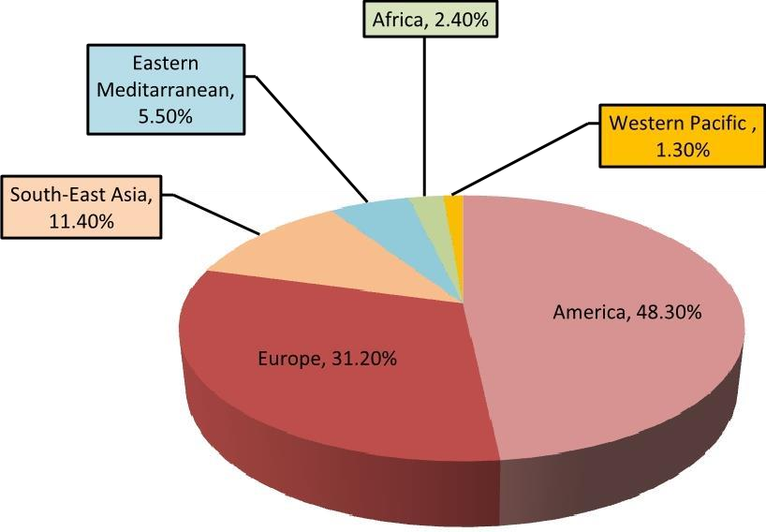

Fig 1.1: Cumulative death cases reported by the world health organization (WHO) from different regions globally are shown in this pie chart.

## Formulation of Problem

A face masks detector machine can be carried out to check this. Face masks detection method to identify whether a person is sporting a mask or now not. The face mask detection is a technique to find out whether the person is wearing a mask or not. In this project We will build a real-time system to detect whether the person on the webcam is wearing a mask or not. We will train the face mask detector model using Keras and OpenCV. We will develop the face mask detector model for detecting whether person is wearing a mask or not. We will train the model using Keras with network architecture. Training the model is the first part of this project and testing using webcam using OpenCV is the second part. The dataset we are working on consists of 1376 images with 690 images containing images of people wearing masks and 686 images with people without masks. we will test the results of face mask

detector model using OpenCV. The proposed model can be integrated with computer or laptop cameras allowing it to detect people who are wearing masks and not wearing masks. The model has been put together using deep learning and classical machine learning techniques with opencv, tensor flow and keras.

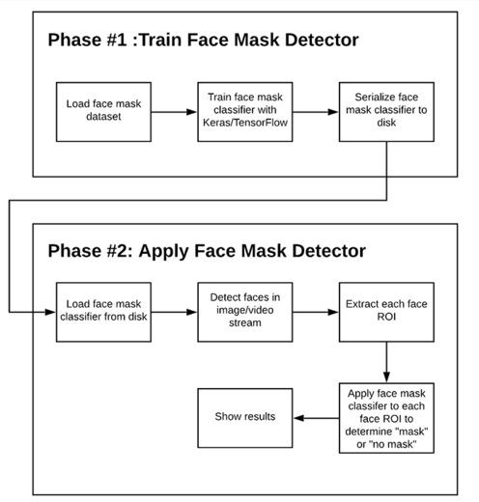

Fig 1.2: Two-phase COVID-19 face mask detector

In order to train a custom face mask detector, we need to break our project into two distinct phases, each with its own respective sub-steps (as shown by **Figure 1** above):

* + 1. Training: Here we’ll focus on loading our face mask detection dataset from disk, training a model (using Keras/TensorFlow) on this dataset, and then serializing the face mask detector to disk
    2. Deployment: Once the face mask detector is trained, we can then move on to loading the mask detector, performing face detection, and then classifying each face as with_mask or without_mask

**1.2.1 Tool and Technology Used** Category: Machine Learning Programming Language: Python Tools & Libraries: OpenCV,keras Front End: NA

Back End : python

## Chapter2: Literature Survey

In[1]This paper gives an efficient option to screen social distancing practices in public regions in which it is very tough to display manually for one-of-a type modules have been advanced for individual detectionsocial distancing recognition, face detection and face mask category.It presents statistics augmentation strategies to deal with the lack of dataset inside the network.

1. Face detection is achieved and with the help of the two labels which were declared one for coloration and the other for name, faces within the photo are categorized as with mask or without mask. Accuracy percentage is shown in white shade on the top of the image.
2. This smart device routinely opens the door handiest if humans wear face masks and notify folks who does no longer wear mask. It acts as clever door which routinely opens and closes the door and it's miles incorporated with a cellular app which ship notifications to proprietor. The software program advanced within the assignment is ready detecting the face with mask or without mask which identifies someone is sporting face masks and gives us alert (through cellular app). This device is incorporated with a cellular app. cell app let us to realize if someone enters home when human beings are not bodily found in their domestic.
3. In this paper, they have analyzed 4 extraordinary steps of masked face detection and their overall performance. Distance from digicam being extra dependable and correct step in comparison to other steps. Eye line detection is straightforward to enforce but it leads to fake detections in bad decision pix as intensity tiers aren't genuinely distinguishable. Eye detection is reliable but it's miles liable to fake eye

detection. Facial part detection is robust and time eating step. In sure cases, facial component detection may not detect face while person is carrying masks and therefore this is the problem of facial part detection step. even as lot of studies goes on inside the field of computer imaginative and prescient and gadget studying, for detection of numerous activities, these proposed steps will without a doubt deliver insight to some of the feasible methods to discover if character is wearing masks or now not. To further enhance the accuracy of those steps, combination of various functions can be implemented and overall performance can be improved.

1. This paper offered a narrative and meta-analytic overview masking all the existing facemask detection algorithms, thinking about the context of Covid-19.The shortcomings of the present algorithms had been reviewed, and the future challenges were outlined. although a considerable quantity of studies has been targeted on growing an green facemask detection set of rules, they specially focused on the identical set of troubles neglecting some different significant issues. This paper highlighted those shortcomings, which includes, retaining picture-decision all through detection process, shortage of wealthy dataset, express classifications, and others.

In [6] the authors have developed a method to identify how a person is wearing the face mask. They were able to classify three categories of facemask-wearing condition namely correct facemask-wearing, incorrect facemask- wearing, and no facemask- wearing. This method achieved over 98% accuracy in detection.

In [7], the researchers proposed a method for the identification of faces using Generalized Intersection over Union (GIoU) based on Mask R-CNN. They proposed this method to reduce the background noise by correctly identifying the face instead of

bounding box which adds noise to the face features and reduces the accuracy of detection.

Detection of face mask is completely based on python and linking with database so also based on python. By adding firebase library and sending a json data of number of people present, number of people taken responsible to wear mask or number of people without wearing the mask [8]. This value will reflect in app and real time database needs library files to be imported in the device and create a project in firebase database.

The proposed method is presented to generate the accurate face segmentation masks from arbitrary image size. The proposed model also shows the recognizing non- frontal faces. Multiple facial marks in a single frame can be detected [9].

For any arbitrary, The circuit face segmentation and detection using semantic segmentation on any arbitrary. To perform the unmanned semantic segmentation of human face. This method reduces the problem of erroneous predictions and find applications in latest tasks such as facial part detection is also the task[10].

Once the device detects number of people entering and detect whether those people wearing face mask in accurate way and if someone is detected with no face mask then alert notification will be sent [11].

Detection of face mask is completely based on python and linking with database so also based on python. By adding firebase library and sending a json data of number of people present, number of people taken responsible to wear mask or number of people without wearing the mask [12].

In [13] the authors have employed a GAN-based network using two discriminators for the removal of face mask from a face and reconstruct the face without the face mask using the CelebA dataset.

The WHO strongly recommends wearing a facemask in public gatherings and outside because it blocks the transmission of the virus through the nasal or oral cavity [14]

Although vaccines of coronavirus have been invented and their mass distribution has started in early December 2020, they only reduce the complications and morbidity of Covid-19 rather than eradicating the virus. Hence, one of the most efficient and safest ways to protect an Individual from this virus is to wear a face mask [15]

Facemasks (i.e.,cottonfabrics,surgical,N-95) provide from 50%to95% protection against the Covid-19 virus [16].

Another method of successful detection of facemask is using Residual Neural Network (ResNet) which is a very deep CNN. After the outbreak of Covid-19, ResNet and ResNet-50 both are seen being used in facemask detection algorithms. It is observed that DL-based algorithms are best suited in case of object detection earlier [17].

in [18] they improved the YOLO algorithm for detecting the face in a video sequence and compared the accuracy of detecting to the traditional approach. They also used the FDDB dataset for training and testing out the model.

The improvement of YOLO model also has been done by Zhao, et al [19]. They improved YOLO model to detect the pedestrian which address two issues such as leverage real-time saliency through surveillance camera and extract the detail of

distinguished feature.

In 2011, the researchers proposed converting from RGB to YCbCr or HSV to find skin region. After that, they were calculated with the pixels of skin areas and the number of pixels of pictures [20].

In 2017, the ROI areas were processed with Principal Component Analysis (PCA) to create the feature extraction and used KNN, MLP and SVM algorithms for creating some models to predict the outputs [21].

## Chapter3: Implementation

**Dataset Collection:** The dataset was collected from Kaggle Repository and was split into training and testing data after its analysis.

**Training a model to detect face masks:** A default OpenCV module was used to obtain faces followed by training a Keras model to identify face mask.

**Detecting the person not wearing a mask:** A open CV model was trained to detect the names of the people who are not wearing masks by referring the database.

A face masks detector machine can be carried out to check this. Face masks detection method to identify whether a person is sporting a mask or now not. The face mask detection is a technique to find out whether the person is wearing a mask or not. In this project We will build a real-time system to detect whether the person on the webcam is wearing a mask or not. We will train the face mask detector model using Keras and OpenCV.. We will develope the face mask detector model for detecting whether person is wearing a mask or not. We will train the model using Keras with network architecture. Training the model is the first part of this project and testing using webcam using OpenCV is the second part. The dataset we are working on consists of 1376 images with 690 images containing images of people wearing masks and 686 images with people without masks. we will test the results of face mask detector model using OpenCV.The proposed model can be integrated with computer or laptop cameras allowing it to detect people who are wearing masks and not wearing masks. The model has been put together using deep learning and classical machine learning techniques with opencv, tensor flow and keras.

First a base model is generated. This is done my using Keras . First a base model is generated and a head model is generated on top of that. The generated version is then trained with the labeled dataset by way of splitting it into portions. One portion incorporates 75 percentage photographs and it's far used for training. The closing component includes the remaining 25 percent of pictures and is used for testing the version accuracy. After the model is trained, it is able to be used for detection of facemask on human faces. A person without the background. This face is given because the enter to the model which we skilled in advance. This outputs weather there is a mask or not. Another model is educated with the faces of humans. The images used for the training of the model are provided with the name and email address of that person because the labels of those snap shots. that is performed by the usage of Open CV. while an input image is given to the CV version, it detects the face of someone and asks the consumer to provide the name and e mail address of that man or woman so one can be saved in the database. The output of the primary version is given because the input to this version. This face can be in comparison with the folks gift in the database. And if his face matches, then a bounding field will be drawn over his face along with his name on it and an email and Sms could be sent to him that he isn't always wearing a masks. Else, only the phrases "mask" may be gift underneath the bounding box if the individual is sporting a masks and "No mask" if the person is not carrying one. that is done by means of the usage of OpenCV. When an input image is given to the CV model, it detects the face of a person and asks the user to provide the call and e mail address of that man or woman so as to be stored within the database. The output of the first model is given as the enter to this model. This face could be compared with the humans present in the database. And if his face suits, then a bounding box can be drawn over his face along with his call on it and an email and Sms can be sent to him that he isn't always sporting a mask. Else, simplest the phrases

"masks" can be gift under the bounding field if the person is

wearing a mask and "No mask" if the character isn't always carrying one.

## THE PROPOSED METHOD

The proposed method consists of a cascade classifier and a pre-trained CNN which contains two 2D convolution layers connected to layers of dense neurons. The algorithm for face mask detection is as follows:

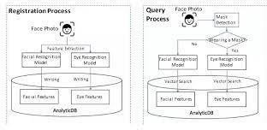

Fig 3.1

## Data Processing

Data preprocessing involves conversion of data from a given format to much more user friendly, desired and meaningful format. It can be in any form like tables, images, videos, graphs, etc. These organized information fit in with an information model or composition and captures relationship between different entities . The proposed method deals with image and video data using Numpy and OpenCV.

* 1. Data Visualization: Data visualization is the process of transforming abstract

data to meaningful representations using knowledge communication and insight discovery through encodings. It is helpful to study a particular pattern in the dataset

. The total number of images in the dataset is visualized in both categories

– ‘with mask’ and ‘without mask’. The statement categories=os.listdir(data path) categorizes the list of directories in the specified data path. The variable categories now looks like: [‘with mask’, ‘without mask’] Then to find the number of labels, we need to distinguish those categories using labels=[i for i in range(len(categories))]. It sets the labels as: [0, 1] Now, each category is mapped to its respective label using label dict=dict(zip(categories,labels)) which at first returns an iterator of tuples in the form of zip object where the items in each passed iterator is paired together consequently. The mapped variable label dict looks like: f‘with mask’: 0, ‘without mask’: 1g

* 1. Conversion of RGB image to Gray image: Modern descriptor-based image recognition systems regularly work on grayscale images, without elaborating the method used to convert from color-to-grayscale. This is because the colortograyscale method is of little consequence when using robust descriptors. Introducing nonessential information could increase the size of training data required to achieve good performance. As grayscale rationalizes the algorithm and diminishes the computational requisites, it is utilized for extracting descriptors instead of working on color images instantaneously . Fig. Conversion of a RGB image to a Gray Scale image of 100 x 100 size We use the function cv2.cvtColor(input image, flag) for changing the color space. Here flag determines the type of conversion . In this case, the flag cv2.COLOR BGR2GRAY is used for gray conversion. Deep CNNs require a fixed-size input image. Therefore we need a fixed common size for all the images in the dataset. Using cv2.resize() the gray scale image is resized into 100 x 100.
  2. Image Reshaping: The input during relegation of an image is a three- dimensional tensor, where each channel has a prominent unique pixel. All the images must have identically tantamount size corresponding to 3D feature tensor. However, neither images are customarily coextensive nor their corresponding feature tensors . Most CNNs can only accept fine-tuned images. This engenders several problems throughout data collection and implementation of model. However, reconfiguring the input images before augmenting them into the network can help to surmount this constraint. The images are normalized to converge the pixel range between 0 and 1. Then they are converted to 4 dimensional arrays using data=np.reshape(data,(data.shape[0], img size,img size,1)) where 1 indicates the Grayscale image. As, the final layer of the neural network has 2 outputs – with mask and without mask i.e. it has categorical representation, the data is converted to categorical labels.

## Training of Model

1. Building the model using CNN architecture:

CNN has become ascendant in miscellaneous computer vision tasks The current method makes use of Sequential CNN. The First Convolution layer is followed by Rectified Linear Unit (ReLU) and MaxPooling layers. The Convolution layer learns from 200 filters. Kernel size is set to 3 x 3 which specifies the height and width of the 2D convolution window. As the model should be aware of the shape of the input expected, the first layer in the model needs to be provided with information about input shape. Following layers can perform instinctive shape reckoning . In this case, input shape is specified as data.shape[1:] which returns the dimensions of the data array from index 1. Default padding is “valid” where

the spatial dimensions are sanctioned to truncate and the input volume is nonzero padded. The activation parameter to the Conv2D class is set as “relu”. It represents an approximately linear function that possesses all the assets of linear models that can easily be optimized with gradient-descent methods. Considering the performance and generalization in deep learning, it is better compared to other activation functions. Max Pooling is used to reduce the spatial dimensions of the output volume. Pool size is set to 3 x 3 and the resulting output has a shape (number of rows or columns) of: shape of output = (input shape - pool size + 1) / strides), where strides has default value (1,1) [15]. As shown in fig, 4, the second Convolution layer has 100 filters and Kernel size is set to 3 x 3. It is followed by ReLu and MaxPooling layers. To insert the data into CNN, the long vector of input is passed through a Flatten layer which transforms matrix of features into a vector that can be fed into a fully connected neural network classifier. To reduce overfitting a Dropout layer with a 50% chance of setting inputs to zero is added to the model. Then a Dense layer of 64 neurons with a ReLu 17 activation function is added. The final layer (Dense) with two outputs for two categories uses the Softmax activation function. Fig. Convolutional Neural Network architecture The learning process needs to be configured first with the compile method . Here

“adam” optimizer is used. categorical crossentropy which is also known as multiclass log loss is used as a loss function (the objective that the model tries to minimize). As the problem is a classification problem, metrics is set to “accuracy”.

1. Splitting the data and training the CNN model: After setting the blueprint to analyze the data, the model needs to be trained using a specific dataset and then to be tested against a different dataset. A proper model and optimized train test split help to produce accurate results while making a prediction. The test size is

set to 0.1 i.e. 90% data of the dataset undergoes training and the rest 10% goes for testing purposes. The validation loss is monitored using ModelCheckpoint. Next, the images in the training set and the test set are fitted to the Sequential model. Here, 20% of the training data is used as validation data. The model is trained for 20 epochs (iterations) which maintains a trade-off between accuracy and chances of overfitting.

## METHODOLOGY

System design The major requirement for implementing this project using python programming language along with Deep learning ,Machine learning , Computer vision and also with python libraries. The architecture consists of Mobile Net as the backbone, it can be used for high and low computation scenarios. We are using Algorithm in our proposed system. Implementation: We have four modules Datasets Collecting : We collect no of data sets with face mask and without masks. we can get high accuracy depends on collecting the number of images . Datasets Extracting: We can extract the features using mobile net v2 of mask and no mask sets Models Training: We will train the the model using open cv,keras (python library). Facemask Detection : We can detect Pre processing image and also detect via live video . If people wear mask, it will permit them, if not then it will give the buzzer to wear mask to prevent them from virus transmission.

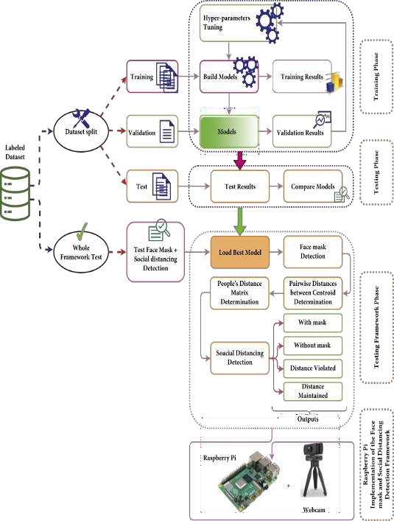

Fig 3.2 Proposed framework for the face mask and social distancing.

## BENEFITS

1. Manual Monitoring is very difficult for officers to check whether the peoples are wearing mask or not. So in our technique, We are using web cam to detect peoples faces and to prevent from virus transmission.
2. It has fast and high accuracy
3. This system can be implemented in ATMs, Banks etc
4. We can keep peoples safe from our technique.

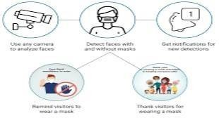

## 3.1 Module Description

**PYTHON:** Python's simplicity, related to its easily readable code, gives programmers confidence in the projects they work on. It's stable, flexible, and gives developers access to a variety of tools that make their jobs easier. Machine Learning projects rely on complex algorithms, leaving very little room for error.

**OPENCV:** OpenCV is a great tool for image processing and performing computer vision tasks. It is an open-source library that can be used to perform tasks like face detection, objection tracking, landmark detection, and much more. It supports multiple languages including python, java C++.OpenCV provides a real-time optimized Computer Vision library, tools, and hardware. It also supports model execution for Machine Learning (ML).

**TENSORFLOW:** TensorFlow is an end-to-end open source platform for machine learning.It is an open source artificial intelligence library, using data flow graphs to build models. It allows developers to create large-scale neural networks with many layers. TensorFlow is mainly used for: Classification, Perception, Understanding, Discovering, Prediction and Creation.

**Dataset:** Data collection is the process of gathering and measuring information from countless different sources. In order to use the data we collect to develop practical artificial intelligence (AI) and machine learning solutions, it must be collected and stored in a way that makes sense for the business problem at hand.

**Train a model to catch face masks:**We will build a real-time system to detect whether the person on the webcam is wearing a mask or not. We will train the face mask detector model using Keras and OpenCV.

**Detect the individual not wearing face mask:**model was educated to discover the names of the people who are not sporting mask by referring the database.

**Numpy,cv2:**OpenCV is a widely usedopen-source library for computer vision. It includes several ready to use computer vision algorithms. Python is becoming the standard programming language for AI and NumPy. provides data structures used to deploy OpenCV with Python.

## Existing Problem-

The existing system deals with CNN (convolutional neural network) in the face mask detection models, they use clustering, classification, max pooling to train the machine on what is what. The CNN trains the machine with the help of dataset, around 20% of the images in dataset are used to train the machine and the remaining 80% is used for testing the results. The face mask detection model empathizes with the problems faced by people around the globe due to COVID-19. This system helps in a small way to stop the pandemic from spreading and festering into our lives further. The Person Identification model or the face recognition model as it is popularly called, uses the face recognition library of python to compare images by similarity detection technique. **Issues in existing system**:

In these existing systems it was impossible for the machine to know who is not wearing a mask and the real-world application for these existing systems were minimal.

## Drawbacks in existing system

The major limitations of existing schemes are as follows: -

CNN used in existing system are slow and resource hungry, which makes the training process slow.

The existing scheme does not detect multiple faces.

The existing system does not detect faces from all angles.

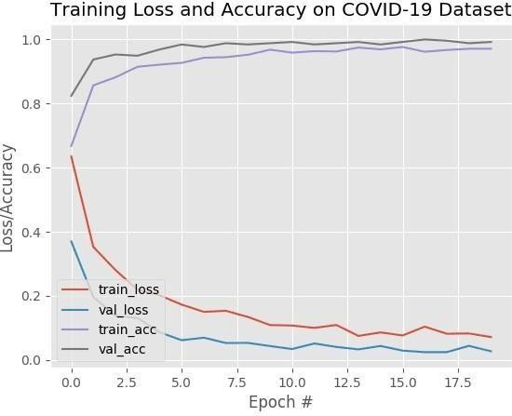

## WORKFLOW DIAGRAM:

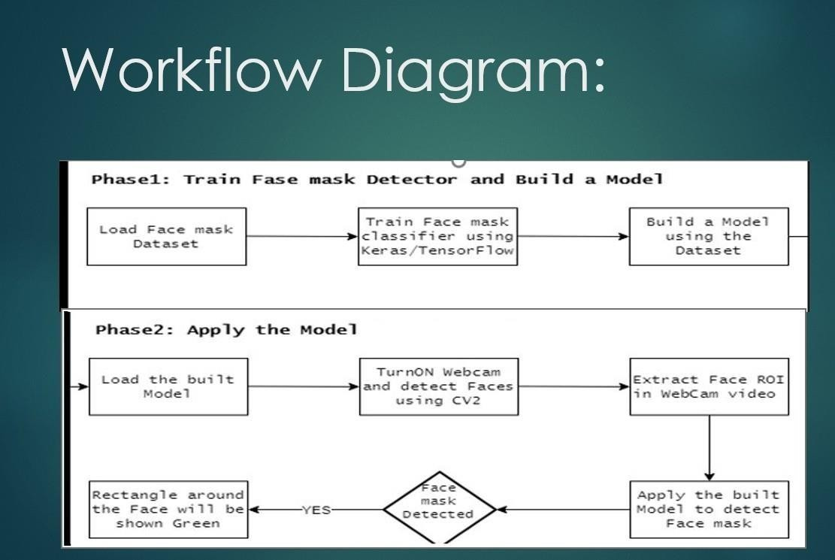

Fig 3.1: FlowChart of the project

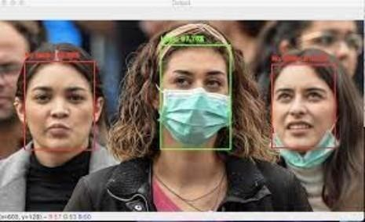

Fig 3.2: Person With Mask and Without Mask

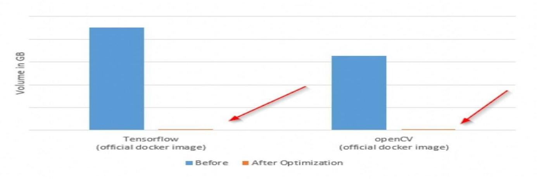

Fig 3.3 Face Mask Detection With ML.

## Chapter4: Experiment and results

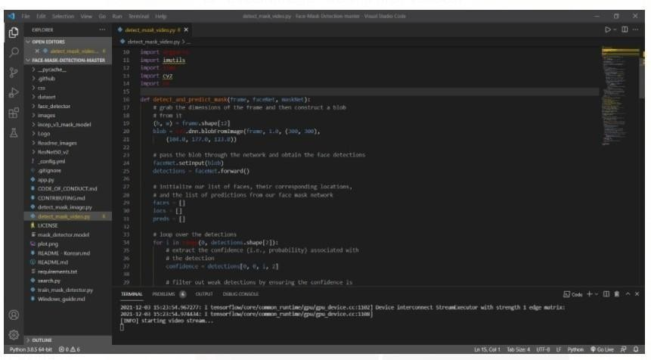 Fig 4.1

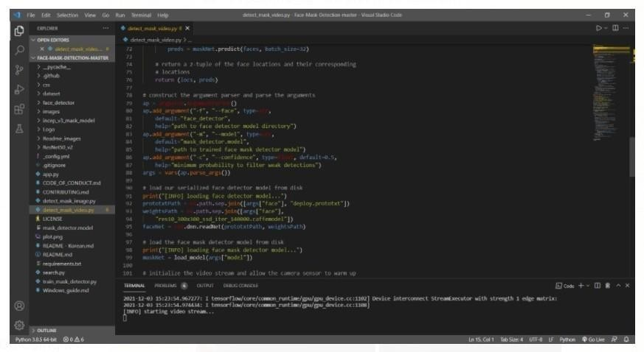

Fig 4.2

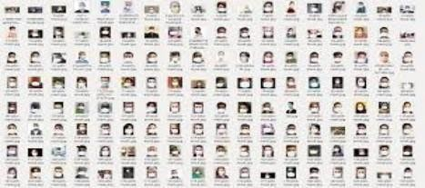

Fig 4.3: Dataset with mask

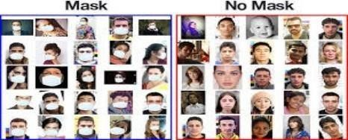

Fig 4.4: Dataset with mask and no mask

## RESULTS:

By preserving a reasonable proportion of different classes, the dataset will partition into training and testing set. The dataset will comprises of 1315 samples in total where 80% will be used in training phase and 20% will get used in testing phase. The develop architecture will trained for 10 epochs since further training results will cause overfitting on the training data. Overfitting generally occurs when a model learns the unwanted patterns of the training samples. Hence, training accuracy increases but test accuracy decreases.

Fig 4.3: When The Person Not Wearing the Mask . A bounding box drawn over the face of the person describes weather the person is wearing a mask or not. If a person’s face is stored in the database, it detects the name of the person who is not wearing face mask.

Mask:

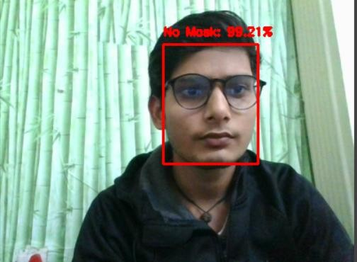

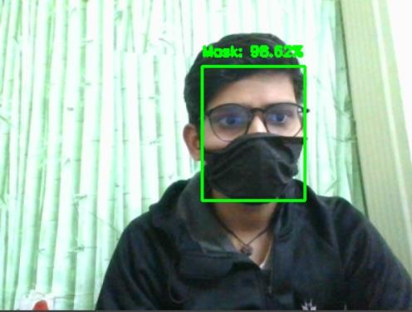

Fig 4.4: When The Person Wearing the Mask . A bounding box drawn over the face of the person describes weather the person is wearing a mask or not. If a person’s face is stored in the database, it detects the name of the person who is wearing face mask.

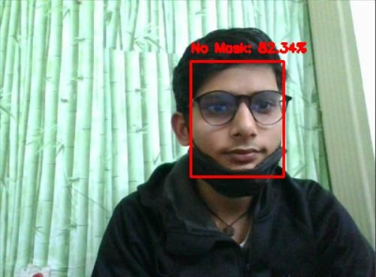 

Fig:4.5: when a person Identifies the not wearing Mask And those details not in the database it try’s Match faces in the database. A bounding box drawn over the face of the person describes weather the person is wearing a mask



Fig 4.6 It detect multiple faces also in a single frame

## 

## Chapter 5: Conclusion and Future Scope

The work proposed in the system focuses on the important challenge faced by the world during the current times due to the ongoing COVID-19 pandemic. The proposed

research work has successfully combined the face mask detection model with the person identification model, which is also be able to send mail notifications to the registered people on our platform who are not wearing a mask. Also, this research work has successfully detected multiple people without wearing a mask or with a mask in a single frame of video. This third eye technology focuses on the complicated work of detecting multiple people at once to ensure that people stay safe in these troubled times by ensuring that they follow the guidelines which are issued by the government.

## 

## 5.2: Future Scope

With the growing quantity of COVID cases all around the global, a machine to update human beings to check masks on the faces of humans is significantly wanted. This system satisfies that need. This machine may be employed in public places like railway stations and department shops. it is going to be of a top notch help in corporations and big establishments where there will be quite a few workers. This gadget may be of a high-quality assist there as it is easy to attain and save the information of the personnel working in that organisation and will very clean locate the folks who are now not sporting the masks and a mail will sent to that respective man or woman to take Precautions not sporting masks, if there data already stored in system.

## REFRENCE:

1. Dhanaraj, R. K., Lalitha, K., Anitha, S., Khaitan, S., Gupta, P., & Goyal, M. K. (2021). Hybrid and dynamic clustering based data aggregation and routing for wireless sensor networks. In Journal of Intelligent &amp; Fuzzy Systems (Vol. 40, Issue 6, pp. 10751–10765). IOS Press. https://doi.org/10.3233/jifs-201756
2. Krishnamoorthi, S., Jayapaul, P., Dhanaraj, R.K. et al. Design of pseudo-random number generator from turbulence padded chaotic map. Nonlinear Dyn (2021). https://doi.org/10.1007/s11071-021-06346-x
3. R. K. Dhanaraj, L. Krishnasamy, O. Geman and D. R. Izdrui, "Black hole and sink hole attack detection in wireless body area networks," Computers, Materials & Continua, vol. 68, no.2, pp. 1949–1965, 2021. doi:10.32604/cmc.2021.015363
4. Ramakrishnan, V., Chenniappan, P., Dhanaraj, R. K., Hsu, C.-H., Xiao, Y., & Al- Turjman, F. (2021). Bootstrap aggregative mean shift clustering for big data anti- pattern detection analytics in 5G/6G communication networks. In Computers &amp; Electrical Engineering (Vol. 95, p. 107380). Elsevier BV. https://doi.org/10.1016/j.compeleceng.2021.107380
5. KRISHNASAMY, L., RAMASAMY, T., DHANARAJ, R., & CHINNASAMY,

P. (2021). A geodesic deployment and radial shaped clustering (RSC) algorithm with statistical aggregation in sensor networks. Turkish Journal of Electrical Engineering & Computer Sciences, 29(3). DOI: 10.3906/elk-2006-124

1. Sathyamoorthy, M., Kuppusamy, S., Dhanaraj, R.K. et al. Improved K-Means Based Q Learning Algorithm for Optimal Clustering and Node Balancing in WSN. Wireless Pers Commun 122, 2745–2766 (2022). https://doi.org/10.1007/s11277-021- 09028-4